|  |  |  |  |  |  |
| --- | --- | --- | --- | --- | --- |
| Date | 7-Dec-22 | | | Tester Name | Richard Belanger |
| Environment | Penfax - Test | | | Login used | TEST2 |
| Operating System | Windows | Version: | Update: | | |
| Software Used | Edge | Version: | Update: | | |
| Not Applicable | Version: | Update: | | |
| Release version | 22.4.1 | | | | |
| Title | M28.02- Attach a document to the member's file  M28.03- Print attached document | | | | |
| Test Type | Regression | | | | |
| Test Scenario | Attach a document to the member’s Inbound Documents | | | | |
|  |  | | | | |
| Expected Results | The document will attach and be viewable/printable | | | | |
| Pass/Fail | Pass | | | JIRA# | N/A |

Describe your steps with screenshots:

Click Add to attach a document

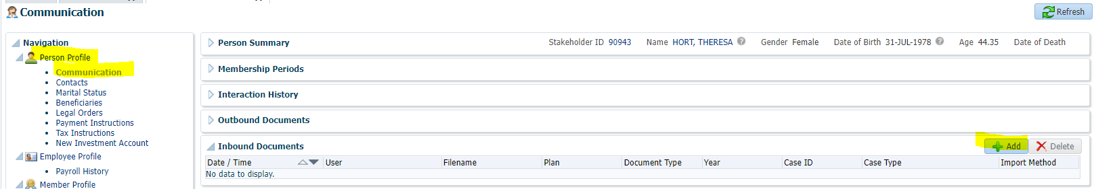

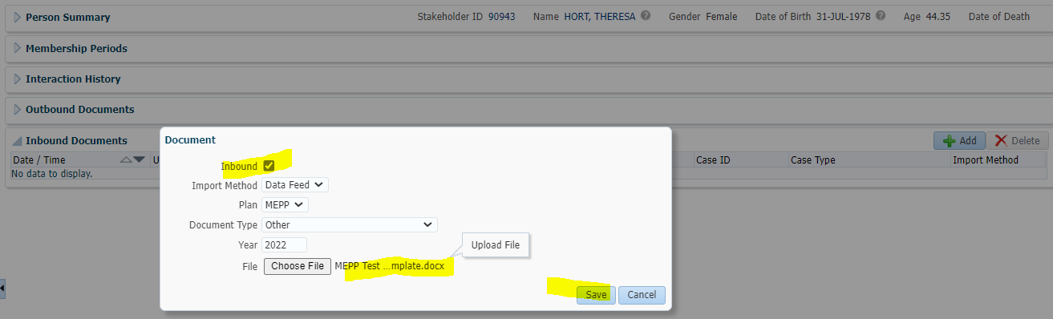

Document Attached

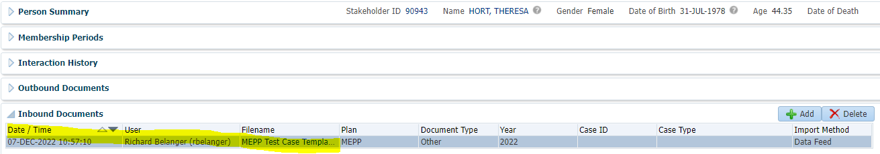

Open document- Click on Hyperlink>Document attached can be opened and viewed

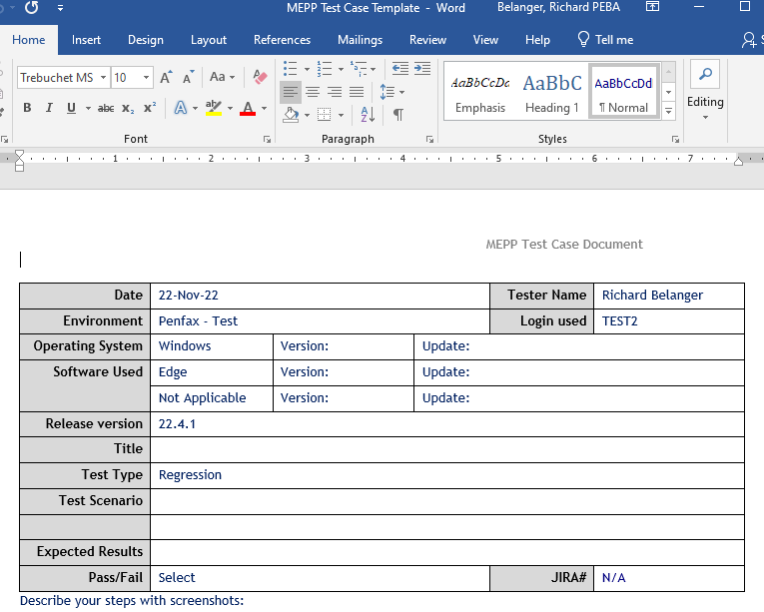

Document can be printed

